**11-etl-Team08:**

Mark Alcocer

John Boer

Kenjicai Brock Dong

**Extraction**

We used 2 datasets from Kaggle and the Yahoo Finance API. Our data was based on video game releases and the parent company’s stock from 2017-2016. The sources for our dataset are as follows

* Video Game Sales .csv from Kaggle.
* Video Game Metacritic Scores .json from Kaggle.
* Company Stock Data from Yahoo API.

**Transformation**

.csv

1. Dropped the unnecessary columns





2. Filtered for desired date range





3. New column for platform company

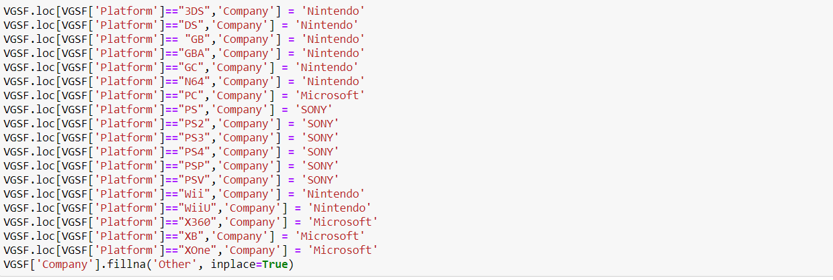

.json

1. Dropped unnecessary columns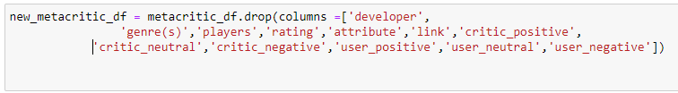
2. Renamed columns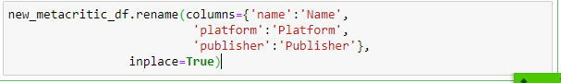
3. Created new column for platform company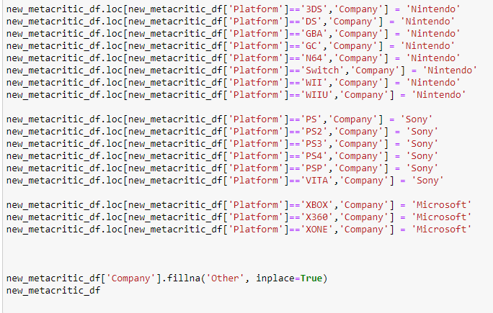
4. Changed MM/DD/YYYY to only YYYY format



1. Filtered for desired date range



Yahoo Finance API

1. Collected financial information for Nintendo, Microsoft, and Sony.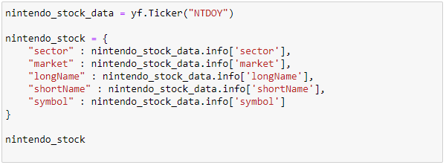

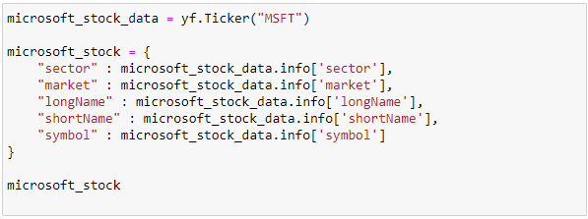

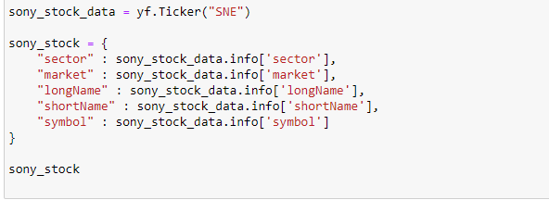

1. Filtered for desired date range







**Load**

The last step was to transfer our final output into a Database. We created a database and respective tables into Postgres.